UAT Checklist
MISSING SOURCE: SCOPE_LOCK
MISSING SOURCE: FORENSIC_ACCOUNT_DOSSIER
Scope note: no separately labelled Scope Lock was provided. I used the signed proposal PDF/page images plus the [REQ] Macro Frozen Customer Narrative Document in-scope / out-of-scope sections as the conservative working scope source. Anything unclear is marked not testable. The working scope basis is: Base MAIA items, recommended customisations, and stated boundaries in the narrative; meeting notes corroborate SQL as master for customer/item data, MAIA as pricing source, Phase 1 core first, AR/price/catalogue customisations later, and delivery/WMS/AP items outside Phase 1.

Step 1 — Scope Inventory
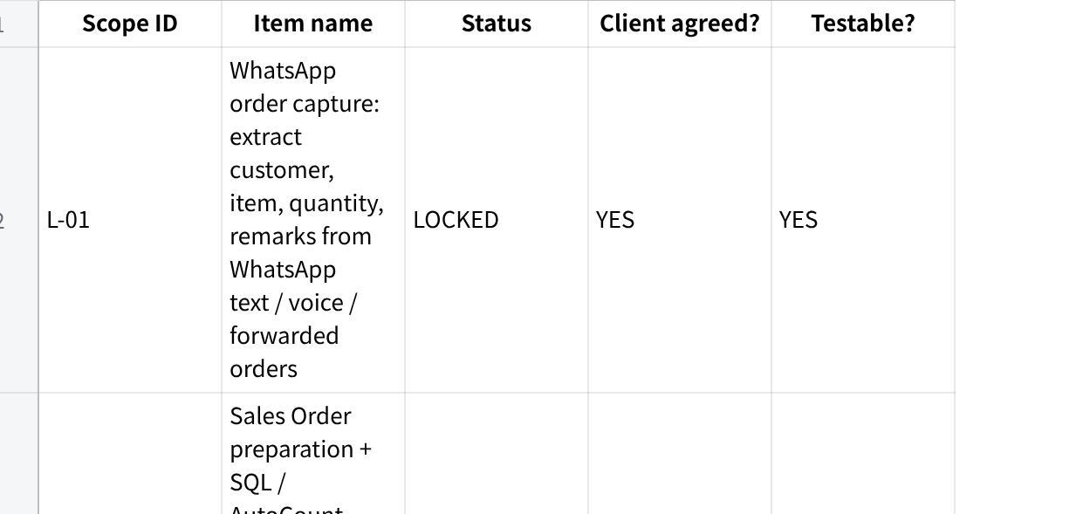
点击图片可查看完整电子表格

Step 2 — Unhappy-Path Bank
The unhappy paths below come from the real workflow: WhatsApp/manual interpretation, weight changes after picking, payer-name mismatch, monthly/market-driven price changes, customer-group pricing, “one invoice” credit discipline, sales rep visibility rules, and explicit must-not boundaries.
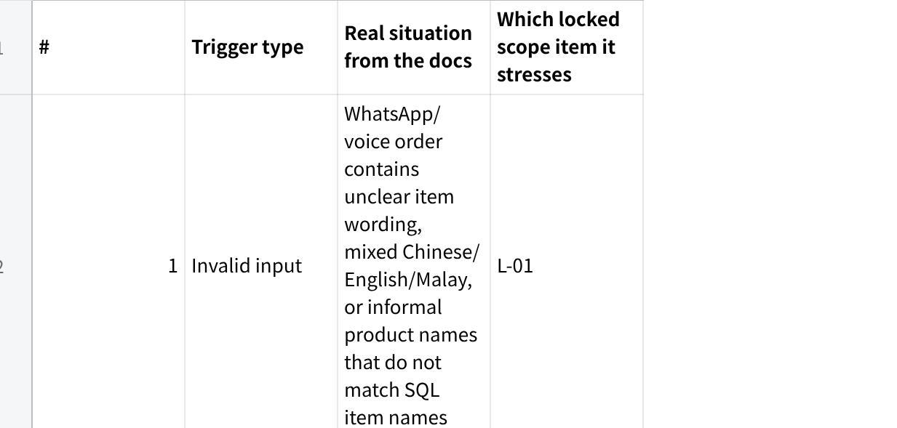
点击图片可查看完整电子表格

Step 3 — UAT Checklist
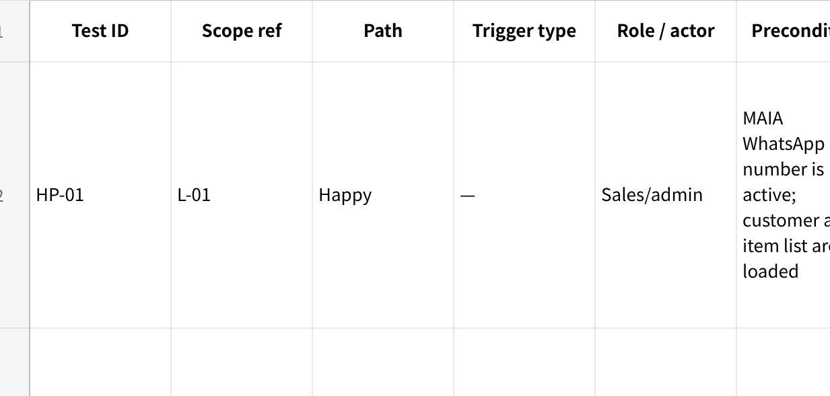
点击图片可查看完整电子表格

Step 4 — Coverage & Traceability Check

4a. Traceability — every locked item is covered
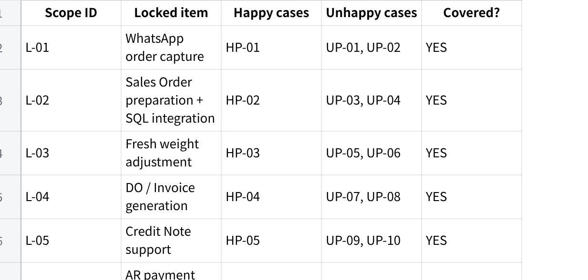
点击图片可查看完整电子表格

4b. Excluded — not tested, and why
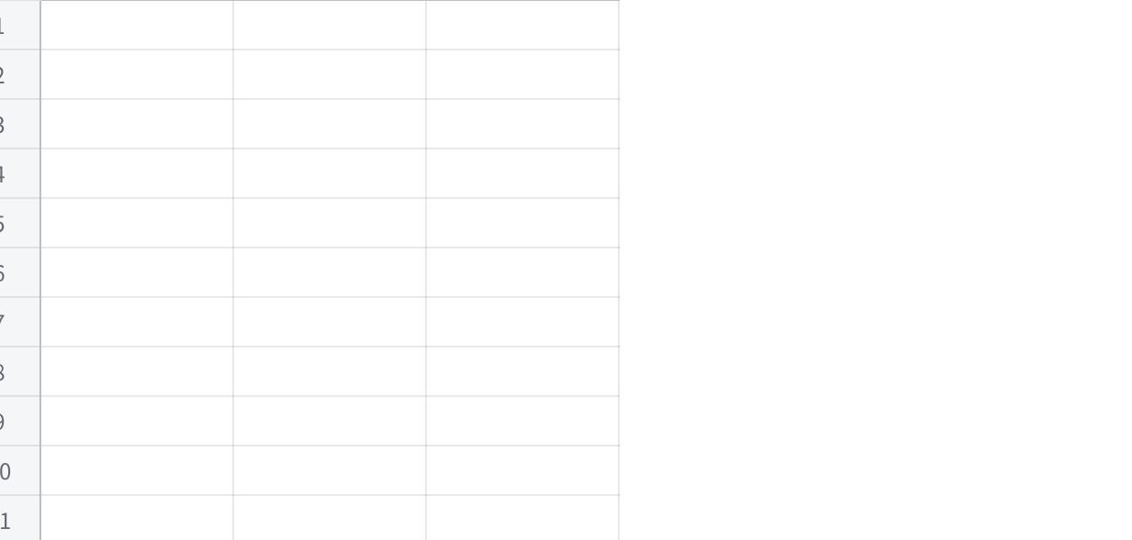
点击图片可查看完整电子表格

4c. Assumptions & gaps

点击图片可查看完整电子表格

Final self-check

点击图片可查看完整电子表格

